
Pool School Packet
- Detailed guide to pool care
- Service and sales options
- Contact information
- Multiport head diagram

Pool Maintenance List

Pump Basket Maintenance
Check Weekly
- Inspect your pump basket at least once a week.
Cleaning Steps
- Turn off the pump and close all valves.
- Remove the pump lid and take out the basket.
- Clean the basket thoroughly.
- Replace the basket and lid, ensuring the gasket stays in place.
- Open the valves and turn the pump back on.
If the Pump Loses Prime
- If no water movement appears after 1–2 minutes:
  - Turn off pump.
  - Close all valves.
  - Remove pump lid.
  - Fill the pump housing with water using a hose or bucket.
  - Replace the lid, open valves, and restart the pump.

Filter & Multiport Valve
(Refer to the attached diagram for multiport head functions.)
Pool Filter Maintenance Guide
- Monitor the Pressure Gauge
  - Check the pressure gauge on your filter’s multiport head three times per week.
  - If the pressure rises above the normal range, backwash immediately to maintain proper water flow and filter efficiency.
- Backwashing the Filter
  - Always backwash at least once per week, even if the pressure gauge hasn’t risen.
  - Steps:
    - Turn the pump off.
    - Turn the valve to BACKWASH.
    - Turn the pump on and run until the sight glass water is clear.
    - Turn the pump off, set the valve to RINSE, and run for 15–30 seconds.
    - Turn the pump off again, return to FILTER, and resume normal operation.
- Draining Water
  - To lower the pool’s water level, use the WASTE setting on the multiport valve.
Key Points:
- Check your pressure gauge three times per week.
- Backwash whenever the pressure gets too high, but always perform a weekly backwash regardless of pressure.
- Regular maintenance ensures clean water, optimal filter efficiency, and protects your pool equipment.
Multiport Head Diagram
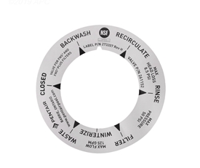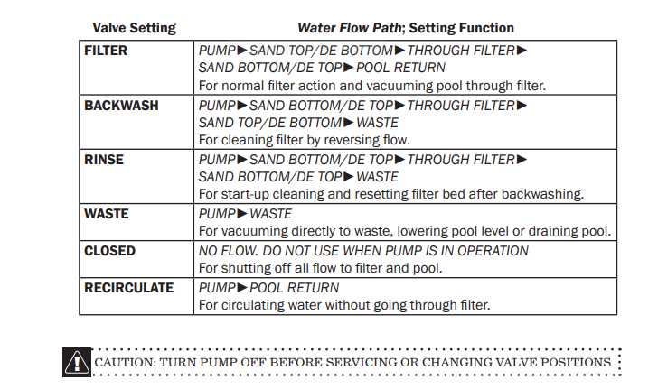

Skimmer Basket Care
- Check and clean your skimmer basket weekly, or daily if your pool usually has a lot of debris.
- Pro Tip: Use a skimmer sock to catch fine debris like pollen and small particles.
- Automatic pool covers help reduce debris accumulation.

Using Your Chlorinator
- Your chlorinator helps maintain consistent chlorine levels in your pool, protecting water quality and equipment.
How to Use:
- Always turn off the pump before opening the chlorinator lid.
- Carefully remove the lid and check chlorine tablet levels.
- Add chlorine tablets (do not overfill; leave space for water flow).
- Restart the pump (while lid is open) and wait for the water to run out of top.
- Put the lid back on the chlorinator (while the water is running out of the top) and make sure it’s secured.
- Adjust the chlorinator control valve as needed — higher settings release more chlorine.
Tips:
- Check chlorine levels at least once a week.
- Ensure the chlorinator is functioning and water is flowing through it.
- Never mix chlorine tablets with other chemicals.
- Regular chlorine flow helps prevent algae growth, staining, and equipment corrosion.
- Clean chlorinator before closing and every time chlorine levels get low.

How to Clean a Chlorinator
- Turn off the pump and make sure the chlorinator is not under pressure.
- Close the valves around the chlorinator if your system has them.
- Carefully open the chlorinator and remove any remaining chlorine tablets.
- Rinse the inside with a garden hose to remove chlorine residue, dirt, and debris. For thicker build up pour hot water to break it loose.
- If there is calcium buildup, use a soft brush or cloth to gently remove it. Avoid metal tools that could damage the plastic.
- Check the lid, O-ring, and fittings for cracks, damage, or buildup. Clean the O-ring and apply the appropriate pool-equipment lubricant if needed.
- Rinse everything thoroughly and replace the chlorine tablets.
- Secure the lid tightly, reopen the valves, and turn the pump back on.
- Check for leaks and make sure the chlorinator is feeding chlorine properly.
Important: Never mix chlorine tablets with other chemicals or cleaners. Always rinse the chlorinator thoroughly before adding fresh tablets.

Salt Cells
Salt cells, also known as chlorine generators, are an essential component of a saltwater pool system. They work by converting salt in the water into chlorine, keeping your pool sanitized without the need for traditional chlorine tablets or liquid.
Key Points:
- Regular Maintenance: Salt cells need routine cleaning to remove calcium buildup and debris. This ensures efficient chlorine production and extends the life of the cell.
- Longevity: With proper care, salt cells can last several years, but they will eventually need replacement depending on usage and water chemistry.
- Water Testing: Regular testing of salt levels and water balance is important to protect the cell, your pool equipment, and your pool liner.
- Troubleshooting: A decrease in chlorine output is often a sign that the cell needs cleaning, that water chemistry needs adjustment, or that water is too cold.
Proper care of your salt cell ensures consistent water sanitation, reduces chemical handling, and keeps your pool safe and sparkling all season long.

How to Use the iClor 30
The iClor 30 is a salt chlorinator that automatically generates chlorine to keep your pool clean and safe. It is easy to operate and allows you to control chlorine output based on your pool’s needs. Usually the iClor 30 is used for pools under 30,000 gallons.

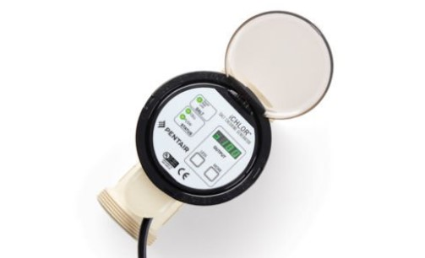

Operating the iClor 30:
- Power and Flow: Ensure your pool pump is running. The iClor 30 requires water flow to operate.
  - When the system is running correctly, the indicator lights should be green.
  - If the pump is off, the flow light will read red, indicating no water is circulating or you need to backwash.
- Adjusting Chlorine Output:
  - Use the “More” or “Less” buttons on the control panel to set chlorine production.
  - The input scale ranges from 1–100:
    - Higher numbers = more chlorine (for heavier use, hot weather, or higher bather load).
    - Lower numbers = less chlorine (for lighter use or cooler conditions).
- Monitoring and Maintenance:
  - Regularly test your pool water to ensure proper chlorine levels, pH, and alkalinity.
  - Check the cell periodically for debris or scaling to maintain efficiency.
  - Adjust the output gradually, rather than making large changes at once, to avoid over- or under-chlorinating.

How to Use the IC40
The IC40 is a high-output salt chlorinator designed for larger pools or pools with heavier usage. It automatically produces chlorine to maintain clean and safe water, with adjustable output for precise control. The IC40 is used for pools above 30,000 gallons.

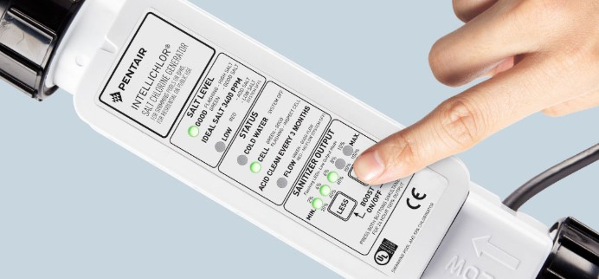

Operating the IC40:
- Power and Flow: Ensure your pool pump is running. The IC40 requires water flow to operate.
  - When the system is running correctly, the flow indicator light will be green.
  - If the pump is off, the flow light will read red, indicating no water is circulating, or you need to backwash.
- Adjusting Chlorine Output:
  - Output settings increase in increments of 2, ranging from 2–100.
  - Low Output Mode: When the LEDs are flashing, the display shows numbers from 2–10, representing lower chlorine production.
  - High Output Mode: When the LEDs are solid, the display shows numbers from 20–100, representing higher chlorine production.
  - Higher numbers = higher chlorine output, suitable for hot weather, heavy bather load, or rapid water contamination.
  - Lower numbers = lower chlorine output, suitable for cooler weather or lighter pool usage.
- Monitoring and Maintenance:
  - Regularly test water chemistry to ensure proper chlorine, pH, and alkalinity levels.
  - Inspect the cell periodically for debris or scaling to maintain optimal efficiency.
  - Adjust output gradually to prevent over- or under-chlorination.
Using the IC40 properly ensures your larger pool remains consistently sanitized, reduces manual chemical handling, and keeps your water clear, safe, and sparkling.

Operating the Hayward Salt Cell:
- Power and Flow:
  - Ensure your pool pump is running. The salt cell requires proper water flow to operate.
  - Make sure your filter is clean and your skimmer and pump baskets are free of debris.
  - The system may display a flow or check-cell warning if there is not enough water moving through the system.
  - If the pump is off or water flow is restricted, the salt system will not produce chlorine.
- Adjusting Chlorine Output:
  - The salt system allows you to adjust the amount of chlorine the cell produces.
  - Higher output settings = higher chlorine production, which may be needed during hot weather, heavy pool use, or periods of high chlorine demand.
  - Lower output settings = lower chlorine production, which may be appropriate during cooler weather or periods of lighter pool use.
  - Make adjustments gradually and allow the system time to respond before making additional changes.
- Maintaining Proper Water Chemistry:
  - Regularly test your free chlorine, pH, alkalinity, calcium hardness, CYA, and salt level.
  - A saltwater pool is still a chlorine pool. The salt cell produces chlorine, but the water still needs to be tested and balanced regularly.
  - Keep the salt level within the range recommended for your specific Hayward system.
  - Proper CYA levels are important because they help protect chlorine from being quickly destroyed by sunlight.
- Inspecting and Cleaning the Cell:
  - Periodically inspect the salt cell for calcium buildup, scaling, or debris.
  - If the cell is dirty or scaled, clean it according to the manufacturer's instructions.
  - Do not scrape the cell plates with sharp objects, as this can damage the cell.
  - Avoid unnecessary acid cleaning. Cleaning the cell too frequently can shorten its lifespan.
  - Always turn off the pump and power to the system before removing the cell.
- Low Chlorine or Salt System Warning:
  - If chlorine is low, first check that the pump is running and there is adequate water flow.
  - Check the salt level and make sure the cell is clean.
  - Test the pool water to determine whether the issue is related to water chemistry or chlorine demand.
  - If the system continues to display a warning or does not produce chlorine after these checks, contact a pool professional for assistance.
Using your Hayward salt system properly and maintaining balanced water chemistry will help extend the life of your salt cell, maintain proper chlorine levels, and keep your pool water clear and clean.

How to Clean a Salt Cell
Regular cleaning of your salt cell ensures efficient chlorine production and prolongs the life of the cell. Over time, calcium and mineral deposits can build up on the cell plates.
Materials Needed:
- Protective gloves and safety goggles
- Plastic bucket (big enough to hold the cell)
- Muriatic acid solution
- Water
- Soft brush (optional, non-metallic)
- Cell stand
Steps:
- Turn Off the System: Always turn off your pool pump and power to the salt chlorinator before removing the cell.
- Remove the Cell: Carefully disconnect the salt cell from the plumbing and electrical connections.
- Inspect the Cell: Look for calcium deposits, scaling, or debris on the plates.
- Prepare the Soak Solution:
  - Use a diluted muriatic acid solution (follow the manufacturer’s instructions carefully).
- Soak the Cell: Poor diluted muriatic acid into one end of salt cell and let soak until bubbling stops. Flip salt cell over to the other end and repeat the same step.
- Scrub Gently (if needed): Use a soft brush to remove stubborn buildup. Do not use metal tools, as they can damage the cell.
- Rinse Thoroughly: Rinse the cell completely with fresh water to remove all traces of the acid.
- Reinstall the Cell: Reattach the cell to the plumbing and electrical connections, ensuring it is securely in place.
- Test the System: Turn on the pump and salt chlorinator. Monitor chlorine output to ensure the cell is functioning properly.
Tips:
- Check your salt cell every 3–6 months, or sooner if chlorine output drops.
- Never attempt to clean a cell while it is connected to power.
- Regular maintenance reduces the risk of expensive cell replacement
Automatic Pool Cover Care (If Applicable)
- Keep the cover clear:
  - Use a cover pump to remove standing water.
  - Use a leaf blower or broom to remove debris, leaves, or snow.
- Yearly Cleaning:
  - Clean the cover and cover box annually to prevent staining, clogging, and damage.
- Daily Venting:
  - Open the cover once daily to release chemical gases, preserving your liner and maintaining healthy water chemistry. Note it’s best to leave open as much as possible.
- Water Level to Support Cover
  - Always keep water level at mid skimmer or above to keep the cover from sinking causing damage to the cover.
Cleaning the Cover Box
Keeping your pool cover box free of debris is important for the proper functioning of your automatic cover and to maintain water quality.
To clean the cover box:
- Access the box: Begin by sliding out the smaller slab at the end of the pool. The slab rests on two metal brackets — gently slide these brackets toward the end of the pool to allow removal of the larger slab.
- Remove the larger slab: Carefully slide out the bigger slab (this may require two people). This provides full access to the cover box.
- Clean the debris: Reach into the box and remove accumulated leaves, dirt, and other debris. For easier cleaning, you can also use a Shop Vac to vacuum out the debris.
- Replace the slabs: Once cleaning is complete, slide the larger slab back into place. Adjust the metal brackets so they fit into the small divots on the slab. Finally, slide the smaller slab back into its original position.
Regularly cleaning the cover box prevents blockages, protects the cover’s mechanical components, and ensures smooth operation throughout the season.
French Drain (If Applicable)
- The French drain helps prevent pool overflow.
- Inspect it regularly to ensure proper drainage.
- For high water tables, monitor it more often.
- If the water level in the drain rises above the shallow depth of the pool, use a pump to remove excess water.

How to Clean Your Hayward Salt Chlorinator Turbo Cell:
- Turn off the power to the system and deactivate the pool pump before removing the Turbo Cell.
- Remove the Turbo Cell. Once removed, look through the cell and inspect for scale formation (light-colored crusty or flaky deposits) on the plates and for debris that is caught on the plates. If no deposits are visible, reinstall the cell.
- If deposits are seen, use a high-pressure garden hose to flush the scale off.
- If a high-pressure hose does not remove the majority of deposits, then use a mild acid wash. Be sure to wear rubber gloves and appropriate eye protection. In a clean plastic container, mix a 4:1 solution of water to muriatic acid (one gallon of water to one quart of acid).
Caution: ALWAYS ADD ACID TO WATER – NEVER ADD WATER TO ACID.
- Fasten the Turbo Cell to Cell Cleaning Stand with the cord side down. Before filling the Turbo Cell with a muriatic acid solution, place a container underneath to avoid any spills. Fill the Turbo Cell to the top with the solution and let soak for 15 minutes. Empty the Turbo Cell and inspect. If clean, rinse with a hose and reinstall. If there are still deposits after soaking, repeat the soaking procedure until clean. The water/muriatic acid mixture can be stored for later use or it can be disposed of. Follow the chemical manufacturer’s recommendations when storing or disposing of the water/acid solution.
- Reinstall the Turbo Cell. Press the small diagnostic button next to the display for 3 seconds to stop the flashing Inspect Cell LED and reset the countdown timer for another 500 operational hours.

Vacuuming & Cleaning Tips

Quick Cleaning for Fine Debris
- For small dirt or sand:
  - Turn off the skimmer valve so all suction is directed to the main drain.
  - Gently brush debris toward the drain.
  - (Not effective for large debris like leaves or rocks.)

Manual Vacuuming
- Ensure water level is at least halfway up the skimmer.
- Brush steps and splash pads before vacuuming.
- Adjust suction by turning the main drain valve halfway or fully off.
Filling the Vacuum Hose
- Turn off pump and turn multiport to the waste option.
- Attach the vacuum head and tele pole to one end of the hose (usually blue or gray).
- Submerge the hose slowly to fill it with water (or fill via hose or return jet).
- Attach the white end of the hose to the skimmer plate, ensuring the black gasket is in place.
- Attach the skimmer plate to the skimmer hole.
- Turn pump back on.
- You should feel strong suction; the plate should be difficult to remove.
After Vacuuming
- Turn off pump.
- Remove vacuum plate and take vacuum head out of the water.
- Slowly drain hose in a good area.
- Turn valve on multiport back to filter and turn on pump.
If Suction Is Weak or Lost
- Turn off pump.
- Remove the vacuum plate.
- Refill the hose with water and reattach.
- If the pump still won’t prime:
  - Turn off the pump and close valves.
  - Remove the pump lid, add water, and replace the lid.
  - Open valves and restart the pump, allowing 1–2 minutes for prime.
Tip: Priming takes practice — be patient!
Alternative Options:
Ask us about automatic or robotic cleaners if manual vacuuming becomes too time-consuming. Note that although automatic or robotic cleaners help aid in the vacuuming process you should still know how to use the manual vacuum option as it will be helpful in phosphate clean ups.
Importance of Manual Vacuuming
Manual vacuuming is an important part of pool care because it removes fine debris, dirt, and algae that automatic cleaners often miss—especially on steps, corners, and ledges. Regular vacuuming helps keep your water clear, prevents buildup that can lead to algae or staining, and protects your filtration system from excess strain. It’s also a great time to spot early signs of wear or damage.

Automatic Pool Cleaners
Automatic pool cleaners are a convenient way to help keep your pool clean between manual vacuuming sessions. They come in three main types — suction-side, pressure-side, and robotic — each designed to remove debris and maintain water clarity with minimal effort.
Benefits of Automatic Cleaners:
- Saves time: Reduces how often you need to manually vacuum.
- Improves circulation: Helps move water and distribute chemicals evenly.
- Protects your filter system: Collects debris before it reaches the filter, extending its lifespan.
- Maintains appearance: Keeps the pool floor and walls looking clean on a daily basis.
While automatic cleaners are efficient, they don’t replace the need for occasional manual vacuuming. Manual cleaning allows you to reach problem areas and remove fine debris or algae that automatic systems may miss. Using both together creates a complete maintenance routine that keeps your water crystal clear and your pool equipment running smoothly.

Opening and Closing Your Pool
Properly opening and closing your pool each season is crucial to protect your investment, maintain water quality, and extend the life of your equipment.
Best Times:
- Opening: Early spring, when temperatures are consistently above 60°F (April- May)
- Closing: Late fall, before the first freeze and once temperatures consistently fall below 65°F (October- November)
Timing your pool opening and closing correctly helps prevent damage to your liner, pumps, and motors, and ensures your water stays clean and balanced throughout the season.

Hayward & Pentair Pool Heater Basics
Your pool heater is designed to help extend your swimming season and maintain a comfortable water temperature. Whether your pool has a Hayward or Pentair heater, proper operation and regular maintenance are important.

How to Operate Your Heater
- Make sure the pool pump is running before turning on the heater.
- The heater requires proper water flow to operate.
- Set the desired temperature on the heater's control panel or compatible automation system.
- Allow time for the pool water to gradually heat. Heating time will depend on the size of your pool, outside temperature, weather conditions, and whether a pool cover is being used.
- Do not turn the heater on and off repeatedly. Once your desired temperature is set, allow the heater time to operate.

Important Things to Know
- Always keep the water level at the proper level to ensure adequate water flow to the equipment.
- Keep baskets, filters, and other equipment clean to help maintain proper circulation.
- Low water flow can cause the heater to display an error code or shut down for safety.
- If your heater displays an error message, write down the code before resetting or turning off the equipment.
- Do not attempt to take apart or repair the heater yourself. Contact a qualified pool professional if you are unsure of the problem.

Cold Weather Warning
If temperatures are expected to drop below freezing, your pool equipment must be properly protected. Freezing temperatures can cause serious damage to your heater and other pool equipment. If you are unsure whether your system is protected, please contact us.

Energy-Saving Tip
Using a pool cover when the pool is not in use can help reduce heat loss and may decrease the amount of time and energy needed to heat your pool.

Routine Maintenance
Your heater should be inspected and maintained regularly. Keep the area around the heater clear of leaves, debris, and other obstructions. Proper water chemistry is also important, as unbalanced water can cause damage to your pool equipment over time.
Important: Never operate the heater without proper water circulation. The pool pump should be running and water should be flowing through the system before the heater operates.
Services and Sales Offered by Lovins Select Pool and Spa
Automatic Pool Cleaners
Our robotic automatic pool cleaners are designed to make pool maintenance effortless. Simply place them in your pool, and they run for up to 3 hours at a time, picking up dirt, leaves, acorns, and other debris. Daily attention is minimal — just empty the filter basket as needed and restart every few hours. We have these in stock for sale and for rent!
The Lovins Select Package
Become a Lovins Select Member and enjoy our season-long weekly cleaning service. Members benefit from consistent, professional pool maintenance all season. Just give us a call and we will email a copy of the details.
Scheduled Cleanings
Need a cleaning on demand? Schedule a pool cleaning by calling the store, perfect for keeping your pool in top shape when you need it.
General Service Work
Our expert technicians are ready to handle all your pool service needs. For more information about our services, give us a call or send us an email — we’re happy to help!
Free Water Testing and Consulting
When you purchase chemicals from us, you receive a free advanced water test. Our system provides a detailed printout of your results, including clear recommendations for adjustments. We’ll help you balance your pool efficiently, saving you money and preventing costly mistakes. Getting started is often the hardest part — we make the rest simple!

Contact Us
Have questions or need supplies? We’re here to help!

Phone: 812-657-3215
Address: 2306 Pennsylvania St Columbus IN 47201
Website: Lovinsselectpoolandspa.com
Free Water Testing Available – Stop In Anytime!

